Lab exercises for 4/20/06: Due date 4/28/06

- First, finish the Lab exercises for 4/13/06. Don’t jump to the next task before finishing it.

- This week we want to exercise the A/D converter with a more typical input device. We will use a thermistor with the NetBurner to make a thermometer:

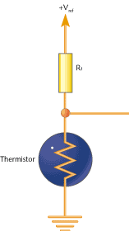

Input to A/D converter

Input to I Inp

- Research thermistors. Describe how they work and explain the relationship between their resistance and their temperature. Normally thermistors are specified by 1) Nominal Resistance, 2) B Constant, and 3)Temperature Coefficient. Explain the thermistor temperature vs resistance curve in terms of these parameters.

- We will be using a Jameco Electronics P/N 207036 thermistor. Go to the Jameco web site and obtain the data sheets for it. Show the voltage input versus temperature curve you expect to observe.

- Write a NetBurner program to test your “system.”

- Construct your thermistor circuit. Use 5 volts for +V (from the NetBurner board – test the voltage using the scope to make certain you are using the correct power pin – same for gnd) and use a 10K resistor for R.

- Test your thermister circuit, first without the NetBurner and then with it. Apply several known temperatures to test it (use a lab thermometer). How do the values compare to those expected?

- Modify your program to directly read out the temperature of your thermistor circuit.

- Determine the accuracy of your thermometer.

